Software Architecture for

Discworld: Ankh-Morpork

**Team Members - 23**

Maniraho, Pascal

Pereira, Gustavo

Desai, Bhavik

Garro Matamoros, Jesus Esteban

Pizarro Ribera, Diego

Contents

**1.** **Abstract** 3

**2.** **Introduction** 3

**3.** **Domain Model** 4

4. **Main Components** 5

5. **Gameplay description** 6

**6.** **Class Diagram** 7

**7.** **Description of Classes and Relationship between main components** 8

**8.** **Software Development Artifacts** 12

**9.** **Conclusion** 12

**References** 12

1. **Abstract**

This document describes the software architecture for a computer-based version of the board game Discworld: Ankh-Morpork. The initial design and the overview of the software architecture contain the basic classes involved and the relationships between them, and is to be incrementally developed.

The first build includes only the following initial features:

* initialize all data structures for a new game,
* load any arbitrary game state from a file in a pre-determined file format.
* save the current game state to a file in the same format used for loading

1. **Introduction**

Discworld: Ankh-Morporkof, a board game designed by Martin Wallace and Treefrog Games.

The game revolves around the playing of cards and placing minions onto the board. Each player attempts to meet the win condition for the personality that they randomly and secretly selected at the start of the game. The game features many characters from the Discworld series but players do not need to have any knowledge about the books.[1].

1. **Domain Model**

The following diagram is based on a basic domain model of the game with its entities and relationships. This diagram is an overview of main components, it does not include some relationships and attributes required on gameplay:

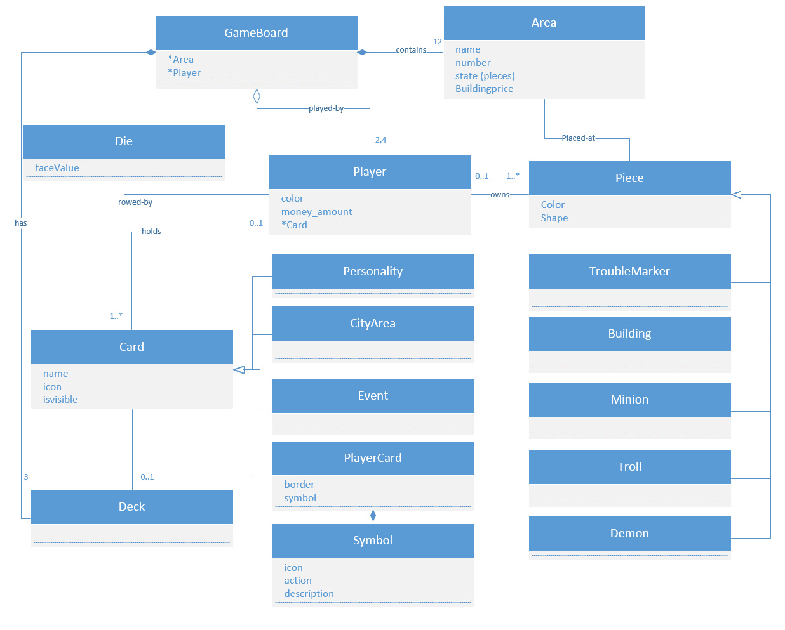

The GameBoard is divided in 12 Areas and can be played by 2 to 4 players. The Player may hold different cards that have different functions during gameplay. At least 1 card is always held by the Player, which is the Personality Card (described later). A Card can be owned by a deck instead of a Player. Players may also own some pieces that are placed in a specific Area of the GameBoard. The game have different types of Pieces that may pertain to a Player of same color. Pieces may be part of gameplay when placed at a specific area. The main components are described in next chapter.

1. **Main Components**

The game has following main components

1. Areas of the Boards :
   1. 12 Areas
      1. Dolly Sisters
      2. Unreal Estate
      3. Dragon’s Landing
      4. Small Gods
      5. The Scours
      6. The Hippo
      7. The Shades
      8. Dimwell
      9. Longwall
      10. Isle of Gods
      11. Seven Sleepers
      12. Nap Hill
2. 4 sets of 12 Minion Pieces (48 pieces in total)
   1. 4 colors
      1. 12 Red
      2. 12 Yellow
      3. 12 Green
      4. 12 Blue
3. 4 sets of 6 buildings with 4 colors
   1. Red(6)
   2. Yellow(6)
   3. Green(6)
   4. Blue(6)
   5. Total building Pieces: 6 x 4 = 24 Pieces
4. 3 Troll pieces
5. 4 Demon pieces
6. 12 Trouble Makers
7. 1 twelve sided die
8. Total 52 Coins :
   1. Silver Coins : 35 x $ 1 = $ 35
   2. Gold Coins : 17 x $ 5 = $ 85
   3. Total Credit: $ 120
9. Player Cards :
   1. 5 Types of cards
      1. 7 Personality Cards
      2. 12 Random Event Cards
      3. 12 City Area Cards
      4. 48 Green bordered player cards
      5. 53 Brown bordered player cards

Number of players: Min 2 & Max 4

1. **Gameplay description**
2. Each player should select a set of playing pieces of the same color.
3. Each player should place one of their minions in the areas *The Shades*, *Dolly Sisters* and *The Scours*. They also should have to place one *Trouble Maker* in all of these three areas.
4. Then shuffle all the personality card and give one card each to all the players. The information about these personality card must be keep secret.
5. All player should assigned 10$ from the bank at the beginning of the game.
6. Shuffle all Random event cards and keep near to the board in such a way that its identity kept unknown.
7. Throw the die and decide the turns that will going to follow during game play.
8. First shuffle Brown bordered player cards and keep on table face down then shuffle Green bordered cards and keep them on the top of the Brown bordered Player card face down.
9. Now distribute 5 cards to each player from these player cards from upside.
10. Keep all City Area cards in such a way that everybody can see it.
11. In a special case if there are only two players playing game then we have to make changes as follows :
    1. Remove Chrysoprase Card from the personality cards.
    2. Remove Hubert and Cosmos Lavish Card from the Brown bordered cards.
12. **Class Diagram**

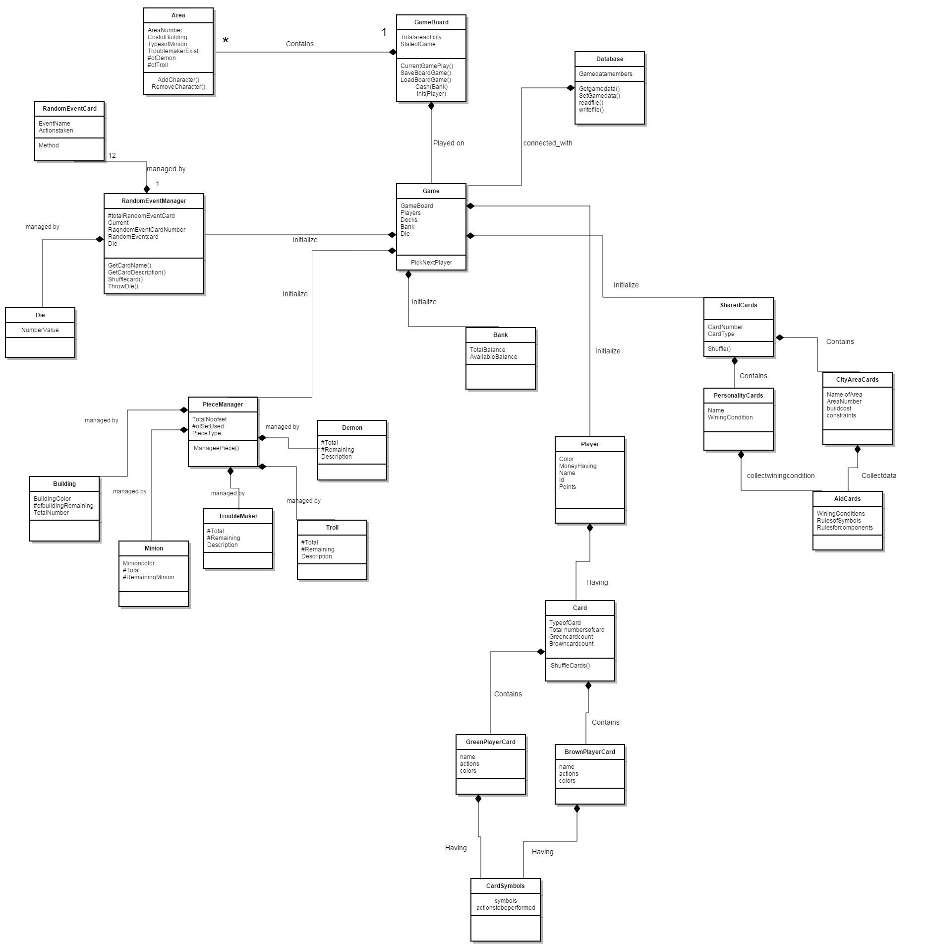

1. **Description of Classes and Relationship between main components**

The player plays his turn by performing all tasks that written on the card, he have to performing all the task written on the card from left to right order. It is not mandatory to perform all the tasks written on the card. Player can perform one or all tasks given on the card. Every player should have 5 cards in his hand at the beginning. And he have to play all the cards and manage card count in his hand as 5.

Player must have to perform the Random Event action.

Rules for placing a Minion:

Minion must be placed in an area where we already have a minion or in the area adjacent to that area. There is no limit on placing number of minions on the area. If we have all our minions on the board then we can remove and change he place of the minion on the board.

Rules for Trouble Maker:

Whenever a minion placed in an area where a minion is already present then we must have to add a trouble maker in that area. An area can contains only one trouble maker. As soon as a minion is moved or removed from an area, any trouble maker from area is also removed. There are mainly two effects of trouble.

a) We only can assassinate the minion if that area contains trouble maker.

b) We cannot build building in an area where we are having a trouble maker.

Rules for placing a buildings:

We can put building in an area where we have a minion. We cannot make building in an area which is having already a building or the trouble maker. The cost placing a building in an area given on the board and on City area card. We have to pay amount to the bank. When building is removed for any reasons we have to return the city area card. We have six buildings on board. If we already have six buildings on the board then we have to remove and replace the building where we want to place the building.

**City Area Cards**:-

**The Shades** – At any point in your turn you can place one trouble marker in The Shades or an adjacent area (area must contain at least one minion).

**Dolly Sisters** – Once per turn you can pay $3 and place one of your minions in Dolly Sisters or an adjacent area.

**The Scours** – Once per turn you can discard one card and take $2 from the bank.

**Dimwell** – Once per turn you can pay $3 and place one of your minions in Dimwell or an adjacent area.

**Nap Hill** – Once per turn you can take $1 from the bank.

**Longwall** – Once per turn you can take $1 from the bank.

**The Hippo** – Once per turn you can take $2 from the bank.

**Dragon’s Landing** – Once per turn you can take $2 from the bank.

**Isle of Gods** – Once per turn you can pay $2 to remove one trouble marker from the board.

**Small Gods** – Whenever one of your minions or buildings is affected by a random event you can pay $3 to ignore the effect. If more than one piece is affected then you must pay $3 for each piece you wish to protect.

**Seven Sleepers** – Once per turn you can take $3 from the bank.

**Unreal Estate** – Once per turn you can draw one card and then discard a card.

**End of Game**:

The game ends when either a player achieves the victory conditions on his or her Personality card OR if the ‘Riot’ Random Event card is drawn and the conditions on the card are met OR as soon as one player takes the last card from the draw pile.

**Personality Cards**:

**Lord Vetinari** – you win if at the beginning of your turn you have a certain number of minions in different areas on the board (think of them as your spies). With two players you need to have minions in at least eleven different areas.With three players you need to have minions in at least ten different areas.With four players you need to have minions in at least nine different areas.Areas must be free of demons.

**Lord Selachii, Lord Rust, Lord de Worde** – you win if at the beginning of your turn you control a certain number of areas. If there are only two of you playing then you need to control seven areas, if there are three of you then you need tocontrol five areas, and if there are four of you then you need to control four areas. You control an area if you have more playing pieces in it than any single other player (a playing piece being a minion or a building). You would also have to have more pieces there than the total number of trolls in the area. You cannot control an area that contains one or more

demons. The presence of a trouble marker does not affect the control of an area.

**Dragon King of Arms** – If at the beginning of your turn there are eight trouble markers on the board then you win. The rationale is that the city has fallen into more chaos than

normal and people want the king back (who would be controlled by you).

**Chrysoprase** – If at the beginning of your turn your net worth (your cash plus the monetary cost of each building you have) is $50 or more then you win the game. Please note that any loans you have taken out count as $12 against your total worth (certain cards allow you to take out loans).

**Commander Vimes** – you win if nobody else wins by the time the draw pile has been exhausted. If the game ends due to the draw pile running out AND nobody has the Commander Vimes Personality card, then the winner is the player with the most points. Each minion on the board is worth five points. Each building is worth a number of points equal to its monetary cost. Each $1 in hand is worth one point. If you have the Dent card or the Bank card then you must pay back the amount noted on the card. If you

cannot do so then you lose fifteen points each. In the case of a tie the tied player with the highest monetary value City Area card is the winner. If there is still a tie then the tied players shared the honours of a joint win.

**Random Events:**

**The Dragon**

Roll the die to determine which area on the board will be hit by the dragon. Remove all minions (including demons and trolls), any trouble marker, and any building from the area affected.

**Flood**

Roll the die twice to see which areas are affected by flood. Areas rolled that are adjacent to the river are affected by flood. In player order, starting with the active player, each player must move their minions from the affected areas to adjacent

areas. You cannot move your minion to another area affected by flood. You can still move to an area adjacent to the river.Buildings, trolls, and demons remain in the areas and are not affected by flooding.

**Fire**

Roll the die to establish the area of the fire. If there is no building in the rolled area then the random event ends without effect. If there is a building in the area then remove it from the board and roll the die again. If the next area rolled is adjacent to the previous area and there is a building in it then remove that building too (the fire has spread). You continue rolling in this manner until you roll an area that either does not contain a building or that is not adjacent to the last area you rolled.

**Fog**

Draw and discard the top five cards from the draw pile. Make sure you and the rest of the players can see which cards have been discarded.

**Riots**

If there are eight or more trouble markers on the board then the game ends immediately. You now work out who has won by adding up points (see page 6). Please note that if a player is Commander Vimes then they do not win at this stage, although they may still win on points.Explosion Roll the die and remove any building in the area of the same number.

**Mysterious Murders!**

You roll one die and remove a minion of your choice from the area of the same number. You then pass the die to the player to your left, who rolls it and removes a minion of their choice from the area of the same number. Repeat this procedure until all players have rolled the die once. If you roll an area and only you have minions there then you must remove one of them.

**Demons from the Dungeon Dimensions**

Roll the die four times and place one demon minion piece in each of the areas matching the numbers rolled. More than one demon can end up in an area. If there is not a trouble marker in the area that a demon is placed in then place such a marker, even if there is no other minion in the area. While there are one or more demons in an area the power on the City Area card cannot be used and any building there has a value of zero. The area also cannot be controlled by any player nor does it count as an occupied area for Vetinari. If an area still has one or more demons in it at the end of the game then nobody scores any points for minions or buildings there. Demons can be moved or removed from the board in the same way as minions.

**Subsidence**

All players must pay $2 for each building they have on the board. If they cannot pay for a building then it is removed from the board. Bloody Stupid Johnson Roll the die. If the City Area Card of the same number is in play then it is set to one side and is no longer in the game, i.e. the power on the card is not in effect. Also, the owner of the card must remove one minion from the same area as the card. The building still counts towards control of the area and retains its monetary value at the end of the game.

**Trolls**

Roll the die three times and place one troll piece in each area of the same number. More than one troll can end up in an area. Remember to place a trouble marker if there is already one or more minions in the area. Trolls are like minions, except they do not belong to any player. They affect your ability to control an area, in that you must treat them as belonging to ‘another player’. You can move or remove them from the board in the same way as a minion.

**Earthquake**

Roll the die twice and remove any buildings from the areas of the same number, if any.

1. **Software Development Artifacts**

Here are some techniques used during development phase:

* Use of incremental software delivery:
* Use of Github as central repository and VCS (versioning control system).
* Use of Design patterns;
* Environment Setup:
  + Eclipse IDE ( Luna or Mars )
  + GitHub software ( Windows, Linux/Mac )
  + Install Maven for Eclipse (m2eclipse - luna/mars depending on version )
* Approach TDD ( Test Driven Development )
* JUnit 4 : TestSuite on src/test/java/GameTestSuite.java
* Code coverage EclEmma Plugin for Eclipse

1. **Conclusion**

As a project to be incrementally developed, this first definition of the software architecture was designed to be simple and do not include features to be implemented on next iterations.

For first build we were able to implement the following GameEngine tasks:

- initialize the game state from a flat file( JSON with GSON )

- have two moves and save another state to the same flat file

- initialize all main components from model ( Player, Gameboard, Cards, Characters )

# **References**

**[1]**  [**https://en.wikipedia.org/wiki/Discworld:_Ankh-Morpork**](https://en.wikipedia.org/wiki/Discworld:_Ankh-Morpork)

**[2] DiscWorld rule book: http://www.treefroggames.com/wp-content/uploads/rules/am-rules-eng.pdf**